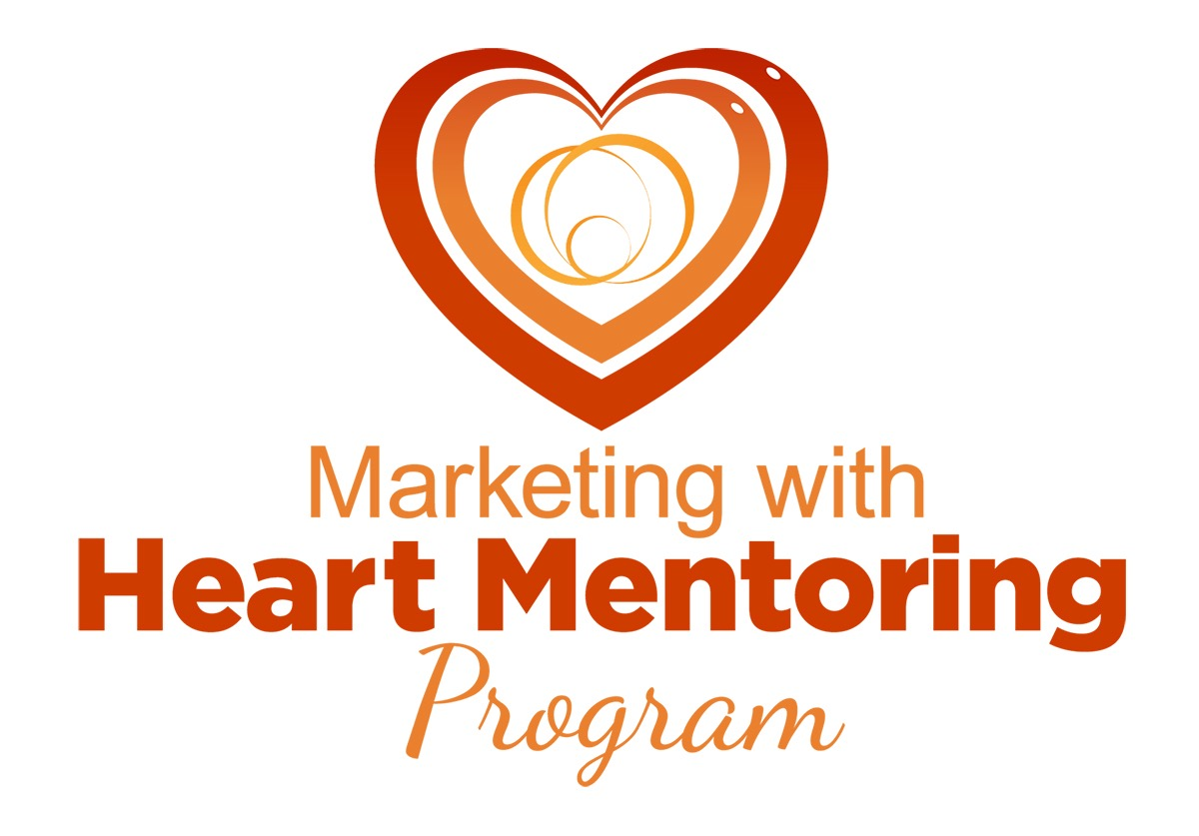

Module 1

Clarify Your Message

By Cindy Schulson

Before we can clarify your message, we need to make sure you’re clear about your niche - e.g. what solution you offer and who you help. We’ll start this journey by looking within you at the solution you’re here to provide.

You may already be clear and that’s great. If so, you’ll be able to breeze through this. Often times, however, we’re not as clear as we may think. So I would encourage you to dig into this material and refine your insights.

Part 1. Clarify Your Solution

You have unique experiences, skills and passions, and you want to leverage those things in your business.

Don’t undervalue what you bring to your business - celebrate it and make it the heart of your business!

As you go through these questions, give yourself the space to brainstorm and think big. Don’t edit yourself. After, we’ll go back through your answers and review for patterns, insights and aha’s.

Start by Looking Within You:

Strengths

What do you do that comes so naturally that you assume everyone else can do it too?

______________________________________________________________________________________________________________________________________________________________________________________________________

What are your natural talents and strengths that you’ve used the most in your personal life? In your professional life?

______________________________________________________________________________________________________________________________________________________________________________________________________

If you were to write a book or give a workshop tomorrow, what would you write/teach about?

______________________________________________________________________________________________________________________________________________________________________________________________________

Experiences

What are 3 success stories you’re most proud of? They can relate to you and/or someone you helped.

Success Story #1:

______________________________________________________________________________________________________________________________________________________________________________________________________

Success Story #2:

______________________________________________________________________________________________________________________________________________________________________________________________________
Success Story #3:

______________________________________________________________________________________________________________________________________________________________________________________________________

Look back at the success stories and identify the skills/strengths you used

Success Story 1:

__________________________________________________________________

Success Story 2:

__________________________________________________________________

Success Story 3:

__________________________________________________________________

What are some of your career highlights?

______________________________________________________________________________________________________________________________________________________________________________________________________

What challenges have you overcome in your personal and/or professional life that you’re most proud of?

______________________________________________________________________________________________________________________________________________________________________________________________________

As you look at the challenges you’ve overcome, how can others benefit from what you learned?

______________________________________________________________________________________________________________________________________________________________________________________________________

Passions

What topic have you always been passionate about and love to learn about?

______________________________________________________________________________________________________________________________________________________________________________________________________

What topic would you most like to help others master?

______________________________________________________________________________________________________________________________________________________________________________________________________

If you were to attend a seminar, what topic would most excite you?

______________________________________________________________________________________________________________________________________________________________________________________________________

What is the biggest contribution you’re here to make?

______________________________________________________________________________________________________________________________________________________________________________________________________

How could you help others by doing what you love to do?

______________________________________________________________________________________________________________________________________________________________________________________________________

Validate by Looking Outside Yourself:

Now that we’ve looked “inside you”, let’s look “outside you” for validation and further clarification.

Testimonials

Review client testimonials to identify recurring themes.

What are some of the biggest challenges your clients were facing when they first came to you?

______________________________________________________________________________________________________________________________________________________________________________________________________

What results did you help your clients achieve?

______________________________________________________________________________________________________________________________________________________________________________________________________

What skills did you use to help your clients achieve the results they did?

______________________________________________________________________________________________________________________________________________________________________________________________________

What qualities do they most value in you?

______________________________________________________________________________________________________________________________________________________________________________________________________

Qualifications

What is your training and education? Include credentials and certifications you’ve received.

______________________________________________________________________________________________________________________________________________________________________________________________________

Claim Your Solution

Go back through your answers and identify recurring themes and patterns. As you review the recurring themes, your goal is to zero in on the main solution you offer. This is the “hook” you will use to get people in your world and the “platform” for which you’ll become famous!

Remember you won’t just offer one solution. You’ll help your clients with many things once they are in your world.

Understand the difference between your solution, outcome and process:

Solution = Main problem you help your clients solve

Outcome = Results you help your clients achieve

Process = How you help your clients achieve that outcome (e.g. coaching)

Based on what you’ve discovered so far, what do you see as the main solution you offer?

__________________________________________________________________

What are the results people get from your solution?

__________________________________________________________________

